Reflective practice
Reflection on your session is an important tool to help you grow and develop. Through
reflection you can be empowered to take responsibility to develop your session delivery,
recognise your progress and above all develop the ability to review and think critically. It is common to reflect on your sessions, but with busy workloads and schedules you can caught up in the next project without the opportunity to draw out a full reflection and act on potential areas you have highlighted as holding you back or room to develop.
A common reflective model used by practitioners is the Gibbs reflective cycle. This isn’t new but has been used by education and professionals for decades and a lot of research has been published on its effectiveness.

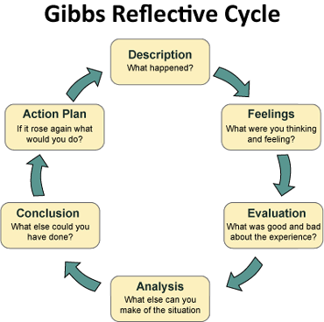

Image credit source: Digital Film Production & Critical Reflection: Gibbs Reflective Cycle (ciqmbc.blogspot.com)

This cycle can be put into a reflective journal for training and projects allowing you to see your progress throughout the year. Here is an example.
Description (what happened?) | Feelings (what were you thinking and feeling?)
12.01.2022 Group wellbeing walk. First session I had delivered. 20 people signed up, 12 people attended. | Nervous how many people would turn up, and worried about the impact of the weather.
Evaluation (your own feedback and that of others) | Analysis (what might have helped and what might have hindered)
The session went well, although only just half the group turned up. A couple of people got cold and found the distance too far.  ‘I enjoyed joining the walk and look forward to coming to another session’  ‘The walk was freezing cold! It was a bit too long for me and if I had known how far it was before I may not have come’. | Lack of information about the route given to participants.  A couple of participants were not dressed appropriately.  A couple of participants emailed me after to say they had forgotten to come.
Conclusion (what else could you have done, what have you learnt, what can you change in the future?) | Action Plan
Clearer information to participants about how long and the walk is and the difficulty.  A way of reminding people about the session so they don’t forget and miss out. | - In the sign-up details clear information about the route/distance/terrain.  - A reminder email the day before the event with suggestions of appropriate clothing and footwear.  - With the walks opportunities to turn back/seek shelter if people are uncomfortable.

